|  |  |  |  |  |  |
| --- | --- | --- | --- | --- | --- |
|  |  |  |  |  | logo1.png |

|  |  |  |  |
| --- | --- | --- | --- |
| Course Name | | Zoho Books | |
| College Name | | Mangayarkarasi College of Arts and Science for Women Paravai, Madurai - 625002 | |
| College Code | | MKU251 | |
| Skill Offering Id | |  | |
| Project Title | | Prepartion and Maintanence of Zoho Books for Dream Homes Realty | |
| Project Submitted To | | Madurai Kamaraj University ( Naan Mudhalvan Scheme(TNSDC)) | |
| Year | | 2023 | |
| Department | | B.COM Computer Application | |
| Semester | | 6 | |
| Group Number | | NM2023TMID36074 | |
| Total Members of the Group | | 4 | |
| Group Members Details | | | |
| Name of the Member | University Register. No | | Student NM ID |
| R.Nithyadharshini | CICI5283 | | 42FD4F99BAD3A8BB30E43DC8C4E9F80F |
| P.Muthu Lakshmi | CICI5279 | | 6968DBFBA7B990F9AFF4E605212496C5 |
| S.Selva Meenakshi | C1C15289 | | 80D551003374C9BBA6F473FE0D2BFD93 |
| M.Munipandi | C1C15278 | | FB2A79E2EA11435A3C245DD7956854CE |
|  |  | |  |
| Under the Guidance | | C.M.Priyanka | |
| SPOC | | Ms.P.UMADEVI | |

**Prepartion and Maintanence of Zoho Books for Dream Homes Realty**

1. **Introduction.**

***1.1 Overview***

**Dream Homes Realty, a construction company, uses Zoho Books to track project expenses, manage subcontractor payments, and handling invoicing. They can generate estimates and invoices for clients, track job costing, and monitor the profitability of each project.**

***1.2 Purpose***

**They can generate estimates and invoices for clients, track job costing, and monitor the profitability of each project. Zoho Books provides them with financial insights to make informed decisions.**

1. **Problem Definition and Design Thinking**
   1. Empathy Map

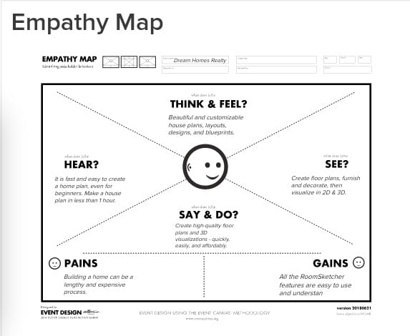

**2.2 Ideation and Brainstroming Map**

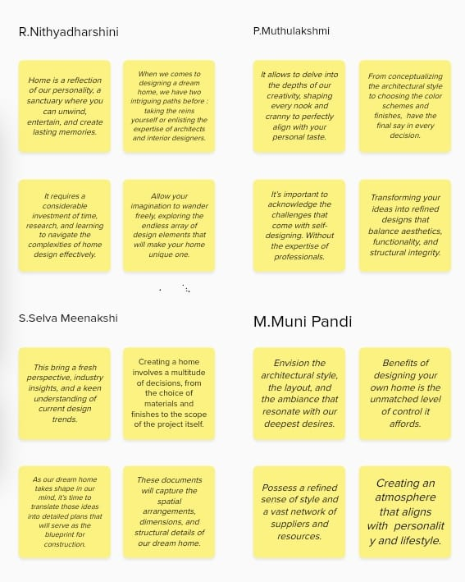

Milestone 1:

Set up your account:

Activity 1:

Sign up for a Zoho Books account and Login

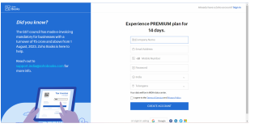

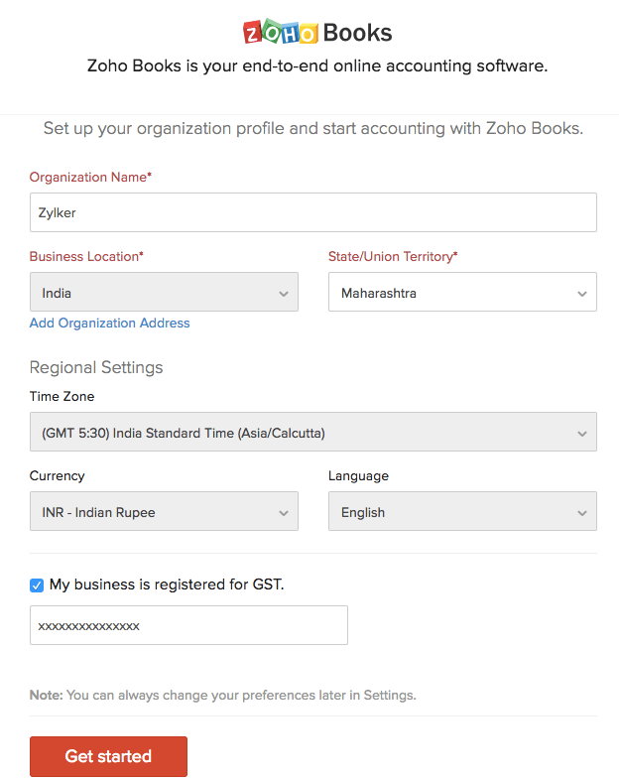

Activity 2:

Introduction

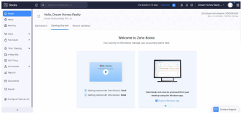

Milestone 2:

Service Cretion:

Activity 1:

Creation

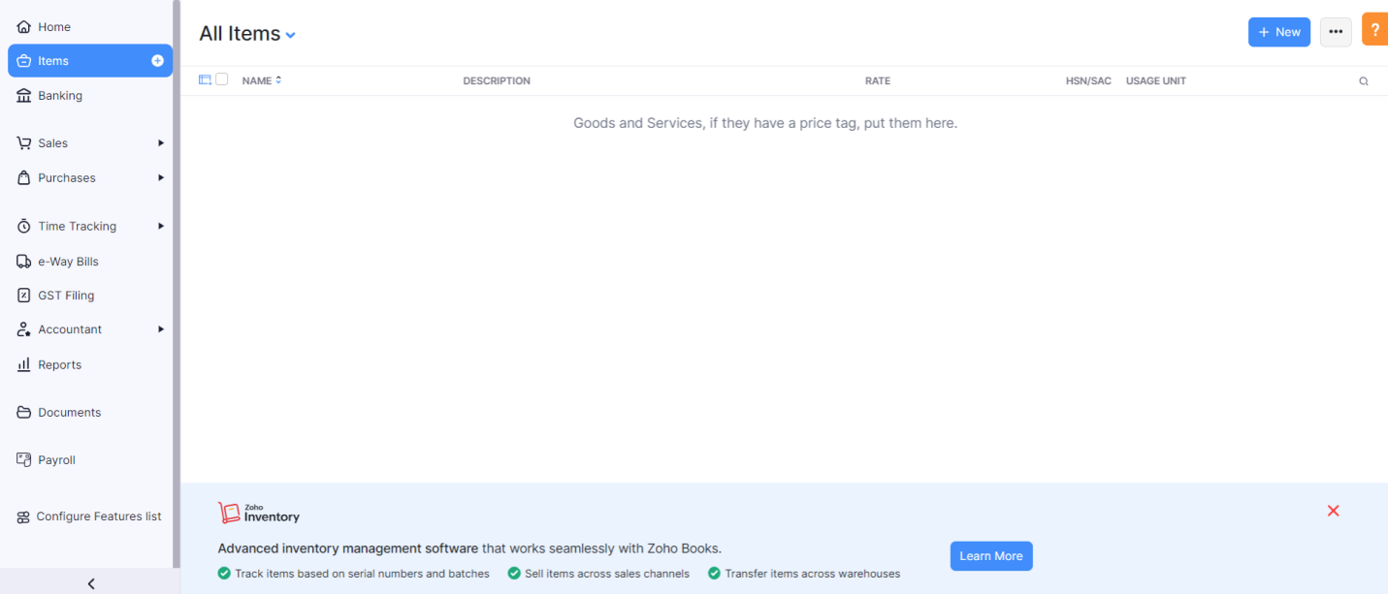

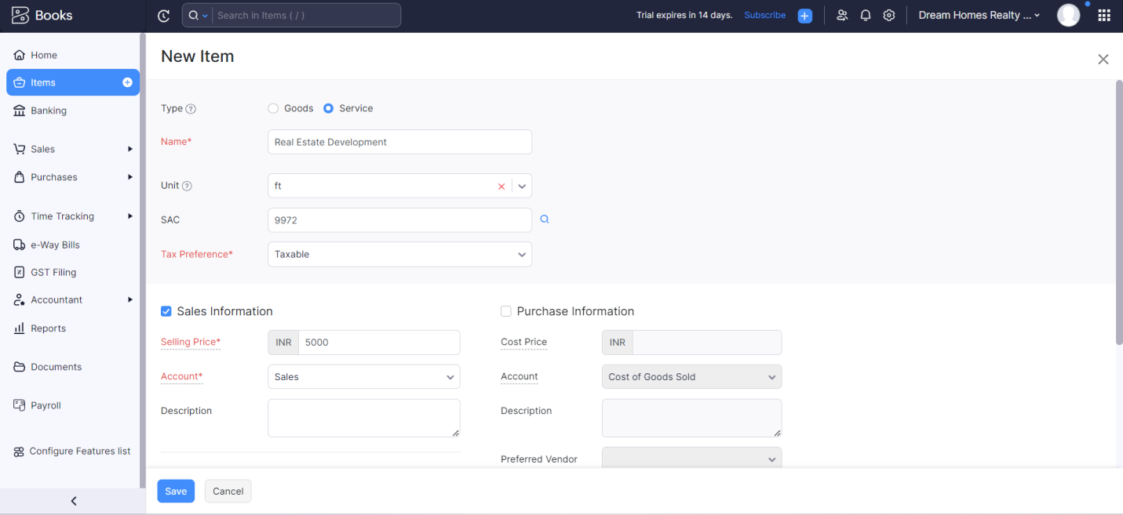

Activity 2:

Review of Items after Addition

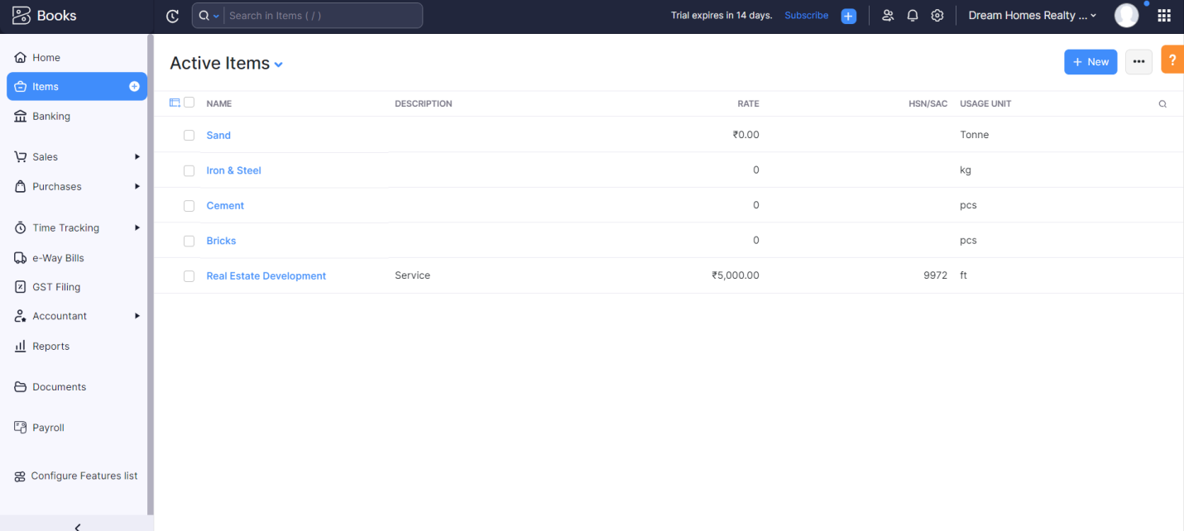

Milestone 3:

Vendors:

Activity 1:

Vendors Creation

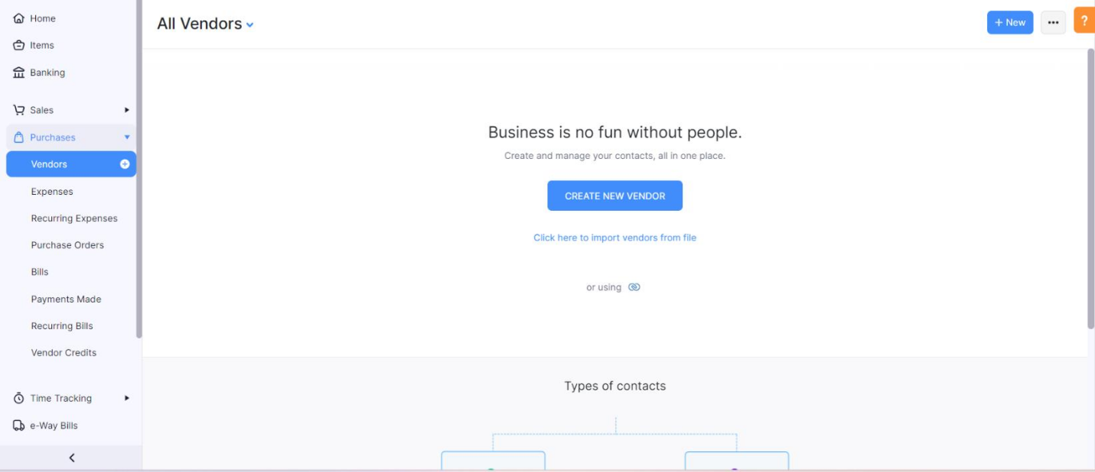

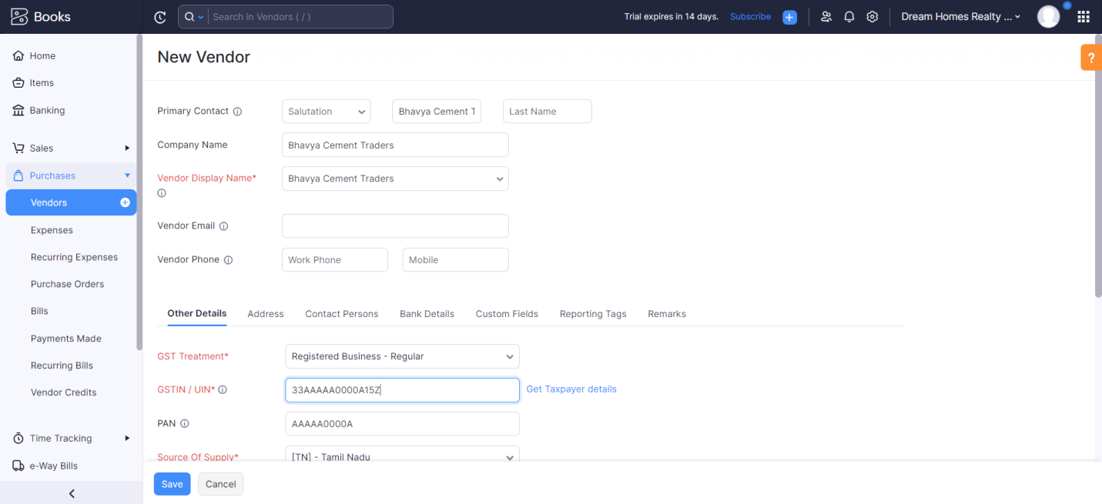

Activity 2:

Review of Vendors List

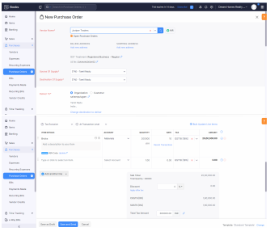

Milestone 4:

Purchases:

Activity 1:

Purchase Order Creation

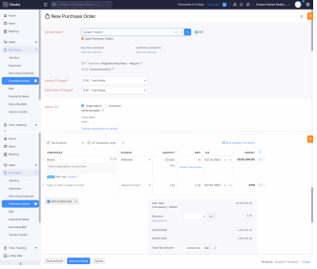

Activity 2:

Purchase Order to Purchase Bills Convertion

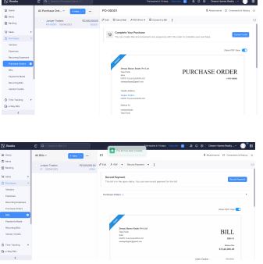

Activity 3:

Direct Vendor Purchase Bills Creation

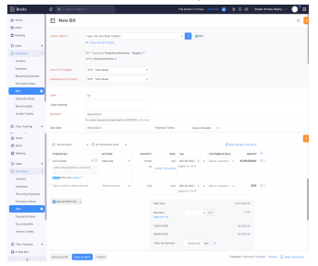

Activity 4:

Reconciliation of Open & Outstanding Bills

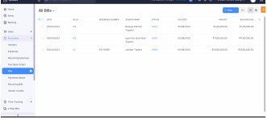

Milestone 5:

Customers:

Activity 1:

Customers Creation

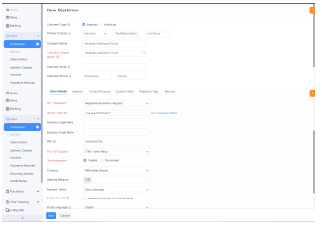

Activity 2:

Review the Customers List

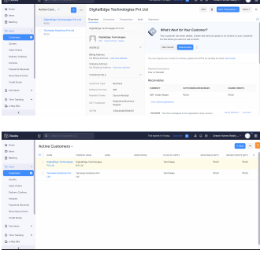

Milestone 6:

Sales:

Activity 1:

Sales Order Creation

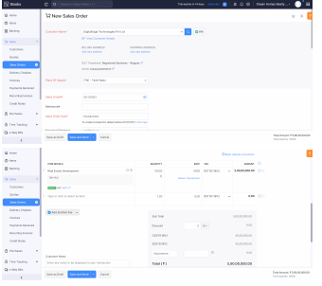

Activity 2:

Sales Order to Sale Invoice Convertion

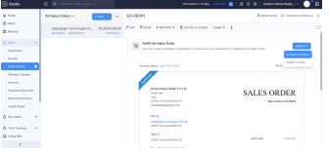

Activity 3:

Direct Sale Invoice

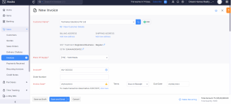

Activity 4:

Reconciliation of Open Invoices

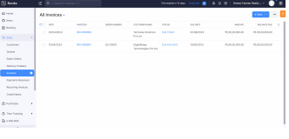

Milestone 7:

Bank Account:

Activity 1:

Adding Bank Account

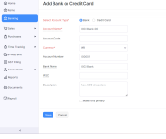

Milestone 8:

Accounts & Ledgers:

Activity 1:

Creation of New Accounts/Ledgers

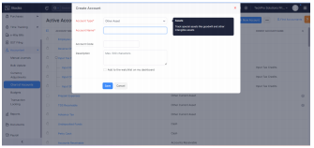

Milestone 9:

Journal Entries:

Activity 1:

Recording of Journal Entries

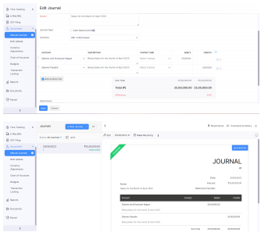

Milestone 10:

Expense & Bills

Activity 1:

Expense & Bills Entry

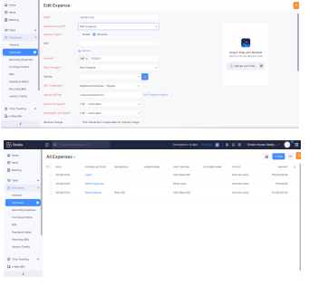

Milestone 11:

Bank Entries:

Activity 1:

Recording of Bank Transactions

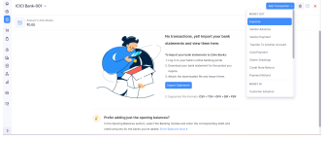

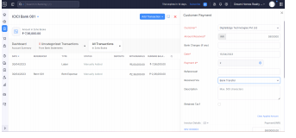

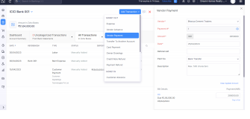

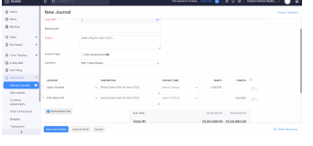

Milestone 12:

Financial Reports:

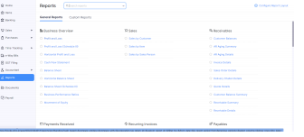

Activity 1:

Profit and Loss Account

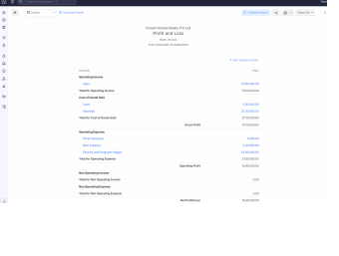

Activity 2:

Balance Sheet

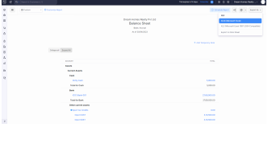

Activity 3:

GST Reports

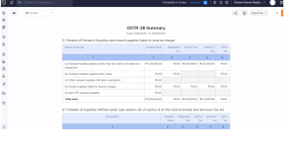

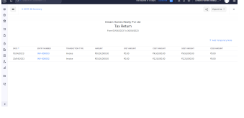

Activity 4:

Journal Report

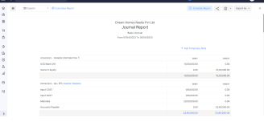

Activity 5:

Accounts Receivable Aging Details

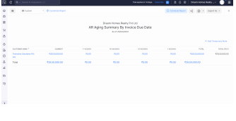

Activity 6:

Accounts Payable Aging Details

